Anexa 1
la Nota privind crearea rețelei de resurse educaționale deschise
Fișa de identificare RED
Nume/prenume autor: SABĂU Laura-Stanca
Denumirea resursei educaționale propuse:
Language Focus – Going Places
Tema/scurtă descriere:
Fișa de lucru abordează tematica de vocabular a manualului Upstream Upper Intermediate, unitatea 6 – Going Places, și anume călătoriile: tipuri de drumuri, de călători și de călătorii. Exercițiile propuse au ca obiectiv fixarea și exersarea terminologiei noi din manual.
Scopul materialului propus:
- didactic (de utilizat la clasă/cu elevii) x
x√
- pentru elev (de utilizat de către elevi)
- de documentare pentru cadre didactice
- altele …………………………………………………….
Nivel de învățământ/clasa: B2 / clasa a X-a
Aria curriculară/disciplina: Limbă și comunicare / Limba engleză
Material extracurricular:
Competențe vizate:
- fixarea de noi cunoștințe
- utilizarea noii terminologii în exerciții suplimentare

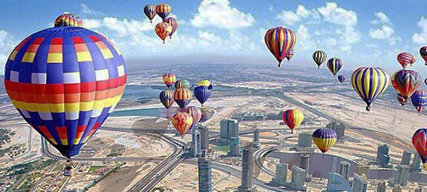
Upstream Upper Intermediate Language Focus
Unit 6 – Going Places
Practice makes you better
- TRAVEL
- Roads
- Match the words in the box with the pictures, then with the correct definition.
bypass motorway track flyover dual carriageway lane ring road
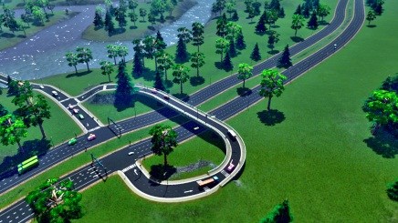
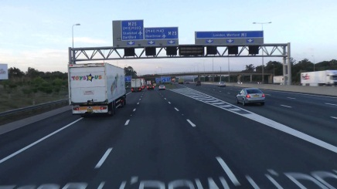
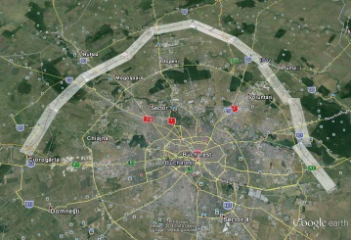

________________________ ________________________ __________________ ___________________
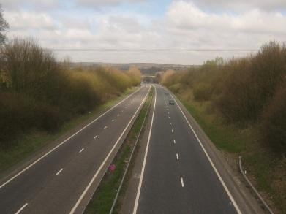
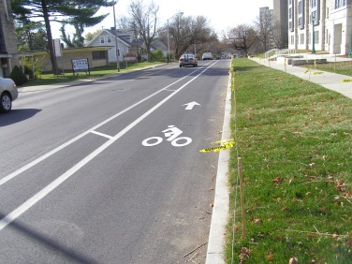
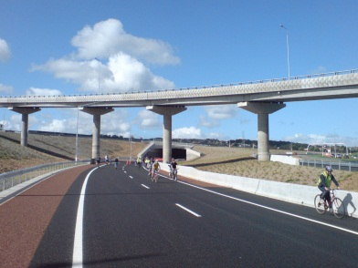

___________________ _____________________ ______________________
- A road that passes around sth , such as a residential area = _________________________________
- A ​narrow ​road in the ​countryside or in a ​town / a ​special ​strip of a ​road, ​sports ​track, or ​swimming ​pool that is used to ​keep ​vehicles or ​competitors ​separate = _________________________________________________
- A ​road that has an ​area of ​land in the ​middle, ​dividing the ​rows of ​traffic that are ​moving in ​opposite ​directions = ______________________________________
- A ​main ​road that goes around the ​edge of a ​town, ​allowing ​traffic to ​avoid the ​town ​centre = _________________
- A ​path or ​rough ​road that is made of ​soil ​rather than having a ​surface ​covered with ​stone or other ​material / a ​type of ​path or ​road, often in the ​shape of a ​ring, that has been ​specially ​designed and ​built for ​sports ​events, ​especially ​racing = ______________________________________
- A ​wide ​road for fast-moving ​traffic, ​especially in the UK, Ireland, and some other ​countries, with a ​limited ​number of ​places at which ​drivers can ​enter and ​leave it = ________________________________________
- A bridge that takes one road above another road = _________________________________________
- Choose one of these words to complete the sentences.
- I find ​driving in the ​fast ________________________ very ​stressful.
- The runners are now on ​their ​final ​lap of the______________________.
- If you take the __________________ you’ll get there 4 hours faster.
- If you are in a hurry and don’t want to cross the city, just go on the ________________________.

- Travellers
The words in bold are in the wrong sentences. Write each word next to the correct sentence.
- A backpacker is a ​person who ​enjoys ​long ​walks in the ​countryside. ________________________
- A globetrotter is someone who ​visits ​interesting ​places. ________________________
- A pilgrim is someone who ​travels to ​places where no one ________________________
has ​ever been in ​order to ​find out what is there.
- A sightseer is someone who often ​travels to a lot of different ​countries. ________________________
- A rambler is a ​person who ​travels with a ​backpack. ________________________
- An explorer is a ​person who makes a ​journey, often a ​long and ​difficult one, ________________________
to a ​special ​place for ​religious ​reasons.

- Trips
- Complete the text with these words:
cruise stopover flight weekend break flying visit excursion day trip extended stay
I just love travelling
Nick and Natalie love travelling. They just can’t stay in one place. They love visiting, exploring, discovering or simply relaxing. Travelling is part of their life together.
They actually met when travelling. Nick was on his office annual _____________ to Singapore. Natalie was going to have an ______________________ (of about one month) to her sister’s in Australia. She had to change her ________ so she decided to have a ______________________in Singapore. She wasn’t in the mood of spending one day in the departure lounge of the airport so she took a _______________________ to the Southern Ridges to walk on the famous trail that links three parks. And there, walking, wandering, inhaling the beauty of Singapore, she bumped into Nick, who was doing the same thing. They started chatting and by the end of the day, they both abandoned their initial plans. Singapore turned into a _________________ of two days, then a romantic___________________ for two in Malaysia, and the travelling never stopped for them.
Now, they are planning to get married on a __________________. They want to combine the luxurious wedding on a large ship with a honeymoon of relaxation and visiting.
- Cruise = a ​journey on a ​large ​ship for ​pleasure, during which you ​visit several ​places.
- Stopover = a ​short ​stay in a ​place that you make while you are on a ​longer ​journey to ​somewhere ​else.
- Flight = a ​journey in an ​aircraft.
- Weekend break = a short holiday (usually at the end of the week.
- Flying visit = a very ​short ​visit.
- Excursion = a ​short ​journey usually made for ​pleasure, often by a ​group of ​people.
- Day trip = a journey that you make for pleasure in which you go to a place and come back on the same day.
- Extended stay = longer than usual.
- Fill in the sentences with one of these words.
- Do you ​fancy coming on a ​_____________________ to Bath next ​Saturday?
- Next ​week we're going on an ____________________________ to Bucharest.
- Our ​tickets to ​USA ​include a _______________________ for two ​nights in Amsterdam.
- My ___________________________ was ​cancelled.
- We are celebrating our 15th wedding anniversary in a ______________________ for two in Florence.
- We went for a ____________________ to my mother's house before continuing on our way to the beach.
Key.
Practice makes you better

- TRAVEL
- Roads
1. Match the words in the box with the pictures, then with the correct definition.
bypass motorway track flyover dual carriageway lane ring road

bypass motorway ring road track

lane flyover dual carriageway
- A road that passes around sth , such as a residential area = bypass
- A ​narrow ​road in the ​countryside or in a ​town / a ​special ​strip of a ​road, ​sports ​track, or ​swimming ​pool that is used to ​keep ​vehicles or ​competitors ​separate = lane
- A ​road that has an ​area of ​land in the ​middle, ​dividing the ​rows of ​traffic that are ​moving in ​opposite ​directions = dual carriageway
- A ​main ​road that goes around the ​edge of a ​town, ​allowing ​traffic to ​avoid the ​town ​centre = ring road
- A ​path or ​rough ​road that is made of ​soil ​rather than having a ​surface ​covered with ​stone or other ​material / a ​type of ​path or ​road, often in the ​shape of a ​ring, that has been ​specially ​designed and ​built for ​sports ​events, ​especially ​racing = track
- A ​wide ​road for fast-moving ​traffic, ​especially in the UK, Ireland, and some other ​countries, with a ​limited ​number of ​places at which ​drivers can ​enter and ​leave it = motorway
- A bridge that takes one road above another road = flyover
2. Choose one of these words to complete the sentences.
- I find ​driving in the ​fast lane very ​stressful.
- The runners are now on ​their ​final ​lap of the track.
- If you take the motorway you’ll get there 4 hours faster.
- If you are in a hurry and don’t want to cross the city, just go on the ring road.
- Travellers
The words in bold are in the wrong sentences. Write each word next to the correct sentence.
- A backpacker is a ​person who ​enjoys ​long ​walks in the ​countryside. rambler
- A globetrotter is someone who ​visits ​interesting ​places. sightseer
- A pilgrim is someone who ​travels to ​places where no one explorer
has ​ever been in ​order to ​find out what is there.
- A sightseer is someone who often ​travels to a lot of different ​countries. globetrotter
- A rambler is a ​person who ​travels with a ​backpack. backpacker
- An explorer is a ​person who makes a ​journey, often a ​long and ​difficult one, pilgrim
to a ​special ​place for ​religious ​reasons.

- Trips
a. Complete the text with these words:
cruise stopover flight weekend break flying visit excursion day trip extended stay
I just love travelling
Nick and Natalie love travelling. They just can’t stay in one place. They love visiting, exploring, discovering or simply relaxing. Travelling is part of their life together.
They actually met when travelling. Nick was on his office annual excursion to Singapore. Natalie was going to have an extended stay (of about one month) to her sister’s in Australia. She had to change her flight so she decided to have a stopover in Singapore. She wasn’t in the mood of spending one day in the departure lounge of the airport so she took a day trip to the Southern Ridges to walk on the famous trail that links three parks. And there, walking, wandering, inhaling the beauty of Singapore, she bumped into Nick, who was doing the same thing. They started chatting and by the end of the day, they both abandoned their initial plans. Singapore turned into a flying visit of two days, then a romantic weekend break for two in Malaysia, and the travelling never stopped for them.
Now, they are planning to get married on a cruise. They want to combine the luxurious wedding on a large ship with a honeymoon of relaxation and visiting.
- Cruise = a ​journey on a ​large ​ship for ​pleasure, during which you ​visit several ​places.
- Stopover = a ​short ​stay in a ​place that you make while you are on a ​longer ​journey to ​somewhere ​else.
- Flight = a ​journey in an ​aircraft.
- Weekend break = a short holiday (usually at the end of the week).
- Flying visit = a very ​short ​visit.
- Excursion = a ​short ​journey usually made for ​pleasure, often by a ​group of ​people.
- Day trip = a journey that you make for pleasure in which you go to a place and come back on the same day.
- Extended stay = longer than usual.
b. Fill in the sentences with one of these words.
- Do you ​fancy coming on a ​day trip to Bath next ​Saturday?
- Next ​week we're going on an excursion to Bucharest.
- Our ​tickets to ​USA ​include a stopover for two ​nights in Amsterdam.
- My flight was ​cancelled.
- We are celebrating our 15th wedding anniversary in a weekend break for two in Florence.
- We went for a flying visit to my mother's house before continuing on our way to the beach.

